


Chapter Quiz

Coding and Programming


Quiz

Chapter 5 For Student

ⓒ2023 SAMSUNG. All rights reserved.
Samsung Electronics Corporate Citizenship Office holds the copyright of this document.
This document is a literary property protected by copyright law so reprint and reproduction without permission are prohibited.
To use this document other than the curriculum of Samsung innovation Campus, you must receive written consent from copyright holder.

Samsung Innovation Campus 2

UNIT 27 Chapter 5 Quiz Bubble, Selection, and Insertion Sort

Q. 27-01

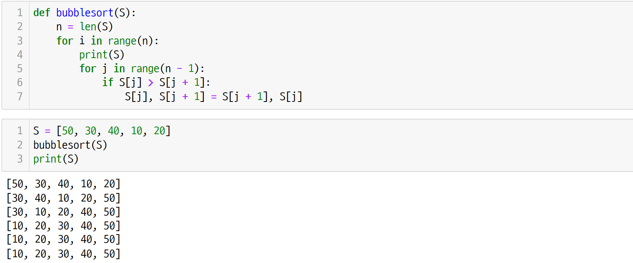
How many swaps were executed in the bubble sort process below?

Samsung Innovation Campus Chapter 5. Algorithm 2 - Sorting Algorithms 3

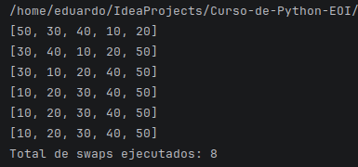
UNIT 27 Chapter 5 Quiz Bubble, Selection, and Insertion Sort

Q. 27-02

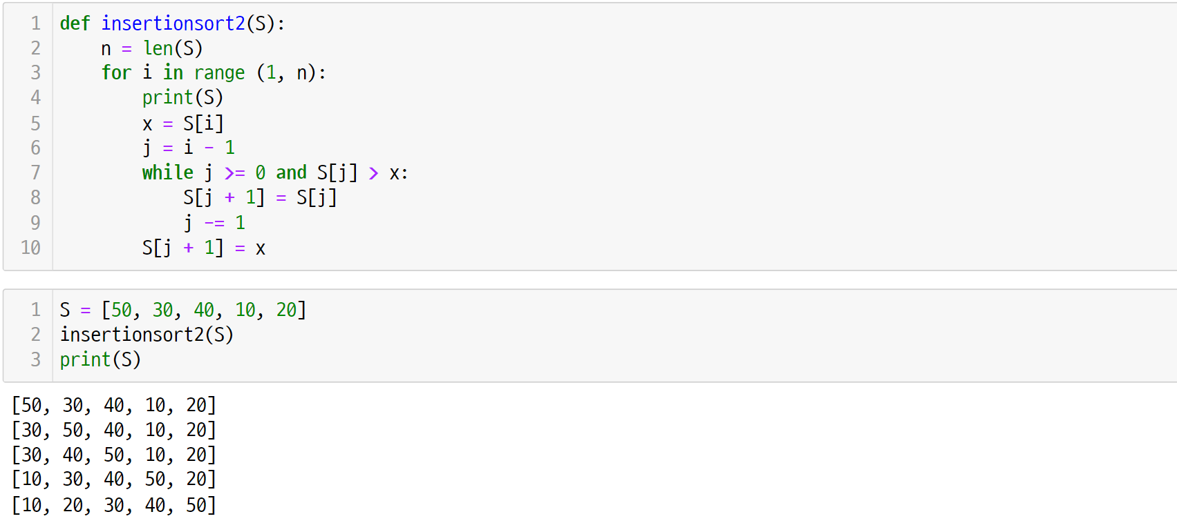
How many comparisons were executed in the insertion sort process below?

Samsung Innovation Campus Chapter 5. Algorithm 2 - Sorting Algorithms 4

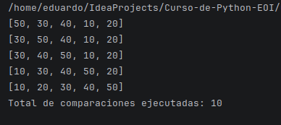

UNIT 28 Chapter 5 Quiz Merge Sort

Q. 28-01

How many times was the merge2() function executed in the merge sort process below?

Samsung Innovation Campus Chapter 5. Algorithm 2 - Sorting Algorithms 5

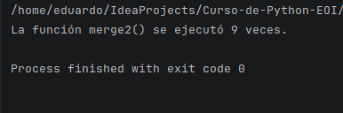
UNIT 29 Chapter 5 Quiz Quick Sort

Q. 29-01

Given the list below, write the output after executing the partition1() function.

Samsung Innovation Campus Chapter 5. Algorithm 2 - Sorting Algorithms 6

